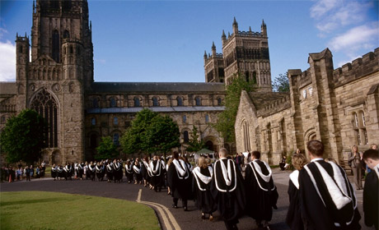



Durham University

+

+

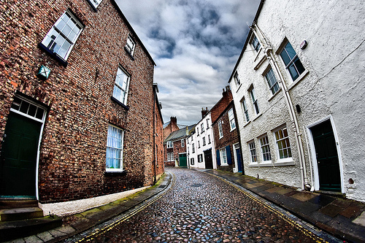

Durham essentially embodies everything that Singapore isn’t – in the right way. Think cobblestone streets, historic architecture, bridges, a winding river, a castle and a Norman cathedral and it’s not hard to see why Durham has previously been voted as England’s favourite city.

Although officially classed as a ‘city’, Durham is really a small and compact university town with an old-world charm. You never really leave the university (unless you go out of town), though slipping away to the riverbanks or into a quaint café, of which there are many, affords one some escape from bustling student life.

Nonetheless, Durham University is a veritable mix of tradition and modernity. Simply put, there is something for everyone – with its sit-down formal dinners and academic gowns, alongside state-of-the-art facilities and thriving student groups of all kinds, Durham continues to appeal to a broad range of students.

**Fast Facts about Durham**

# Academics and Student Life

+

Durham University maintains high academic standards and is particularly noted for its humanities courses. The university offers a wide range of modules such as in Middle Eastern and African studies and foreign languages, as well as inter-disciplinary courses like Politics, Philosophy and Economics (PPE) and International Relations. The Combined Honours programme in arts and social sciences provides a leading alternative for those who seek an American-style, broad-based liberal arts education within the British university system.

Student life in Durham is comprehensive and activities are often available at both a university and college level. Performing arts groups and a whole host of other interest-based societies are always happy to receive prospective members. Sporting culture is particularly strong in Durham and the university has produced not a small number of Olympic medalists!

About Durham…



Student life is often unrelenting in this university, so there are always concerts and other performances being staged, public debates and lectures being held and cultural activities being organised. But for those who simply prefer to hang out with friends on a free night, college bars (every college has one) and the city’s pubs and clubs are only a stone’s throw away. Indeed, bar crawls from college to college is a popular pastime, especially for the *kaypoh*.

For those who wish to get out of the ‘Durham bubble’ from time to time, Newcastle is only 15 minutes away by train and York a mere hour. Those who seek more varied cultural and gastronomical experiences can be satisfied without much difficulty.

Durham has no shortage of cafés with superb brunch sets, classy but affordable Italian restaurants and Asian food (there are even Thai and Chinese supermarkets.)

Despite its small size, there is much to explore within Durham. The rustic and the urban blend together seamlessly, so one can go from exploring walking trails amidst lush greenery to shopping at Topshop and sipping some coffee at Starbucks in the space of an hour.

**Food & Entertainment**

Each college has its own ‘personality’ and traditions; some colleges are bigger and some smaller and more intimate. Different people might be attracted to the different styles of architecture that the various colleges offer. There is friendly rivalry between the colleges, but what is certain is that each college has its own draws.

Whereas university-level sports teams and arts societies may be difficult to get in or too intensive in training, colleges have their own sports groups and societies which tend to be more relaxed and for recreation, though there are inter-collegiate tournaments too!

Like Oxford and Cambridge, Durham maintains the tradition of a collegiate system. More than just glorified halls of residence, colleges in Durham are lively, close-knit student communities providing both social activities and a comprehensive student welfare system (e.g. students are assigned personal mentors from their college staff).

There are 14 colleges in Durham’s main campus and two colleges in Queen’s Campus in Stockton, which is an hour’s bus ride from Durham city and where a few courses like accounting and medicine are primarily taught. Durham city’s colleges can be further categorised into the ‘bailey colleges’ – those situated in the city centre, which tend to be older and more traditional – and the ‘hill colleges’ – a short walk away from the bailey, with more modern buildings. (Yes, everything in Durham is within walking distance.)

**Collegiate System**

+

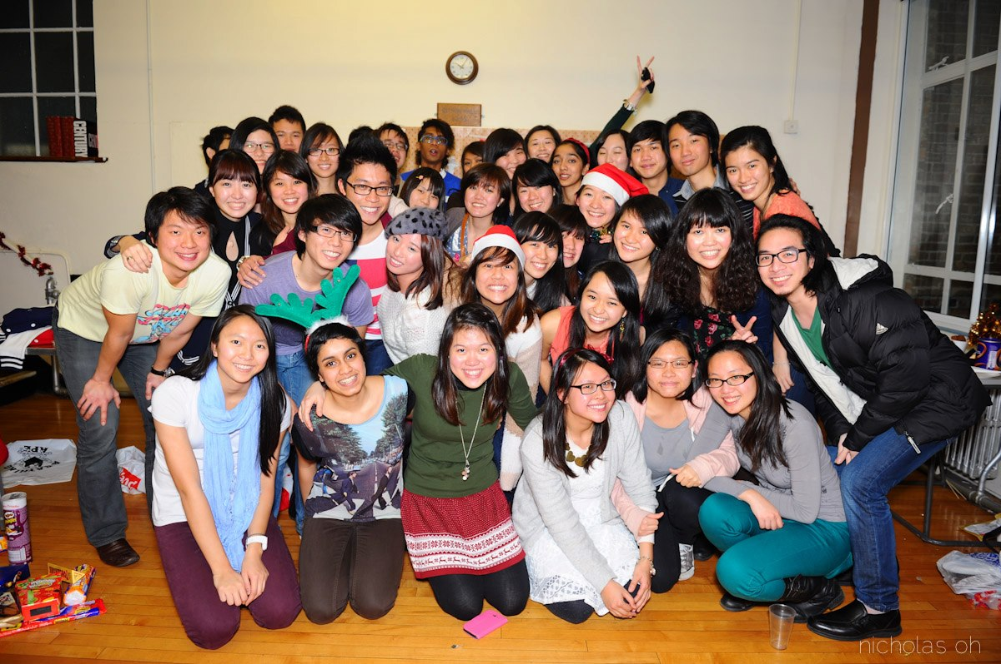

# Singapore Society

## The Singaporean Community

+



**Laura Kho, St Cuthbert’s College**

Durham is a beautiful, historic city and the university is headed by world-renowned scholars and professors. For me, reading English has really been an intellectual joyride! The English Department gives a lot of flexibility and variety in module selection and I can dabble in anything from deconstructing modern film to studying the entire Shakespeare canon.

College life here is extremely vibrant with events of all kinds happening daily. I think that Durham offers a unique experience found in a few other places.

**Chongmin Alicia, Collingwood College**

Durham is an amazing place to be; unlike crowded, sunny Singapore, life here is quieter and slightly more slow-paced (until exam time, that is!). It is a refreshing change from what I’ve been used to. My college has given me a sense of community and warmth and I’ve been able to make friends with both local and international students. The academic support and pastoral care from the staff constantly make Durham a welcoming place to live in. The city is very conducive for studying since Durham is a university town and everything is within walking distance.

I particularly enjoy my course – Combined Honours in arts – because I get to study a wide variety of subjects, like English and Music, and balance depth and breadth. You can’t find this flexibility and freedom to design your own university education anywhere else in the UK!

DUSS is a warm, welcoming community of Singaporean students and is a great way to keep in contact with Singaporean friends from other colleges. Expect lots of gatherings centred around Asian food – for big events like Christmas and Chinese New Year, as well as smaller get-togethers and themed socials throughout the academic year.

The Singapore Society also has its own parent-child system, with one or two seniors attached to each first-year student, to help Singaporeans settle in and adapt smoothly to the new environment. (This also means ‘reunion dinner’ does not go unmarked!)

If you’re looking for a charming city with beautiful grounds, an internationally renowned and academically distinguished university and a varied experience of traditional culture and progressive methods, then Durham University meets all these needs – and many more!

**(If you have any queries, please drop us a line at singapore.society@durham.ac.uk!)**